Lab - OSPFv2 Route Summarization and Filtering

# Topology

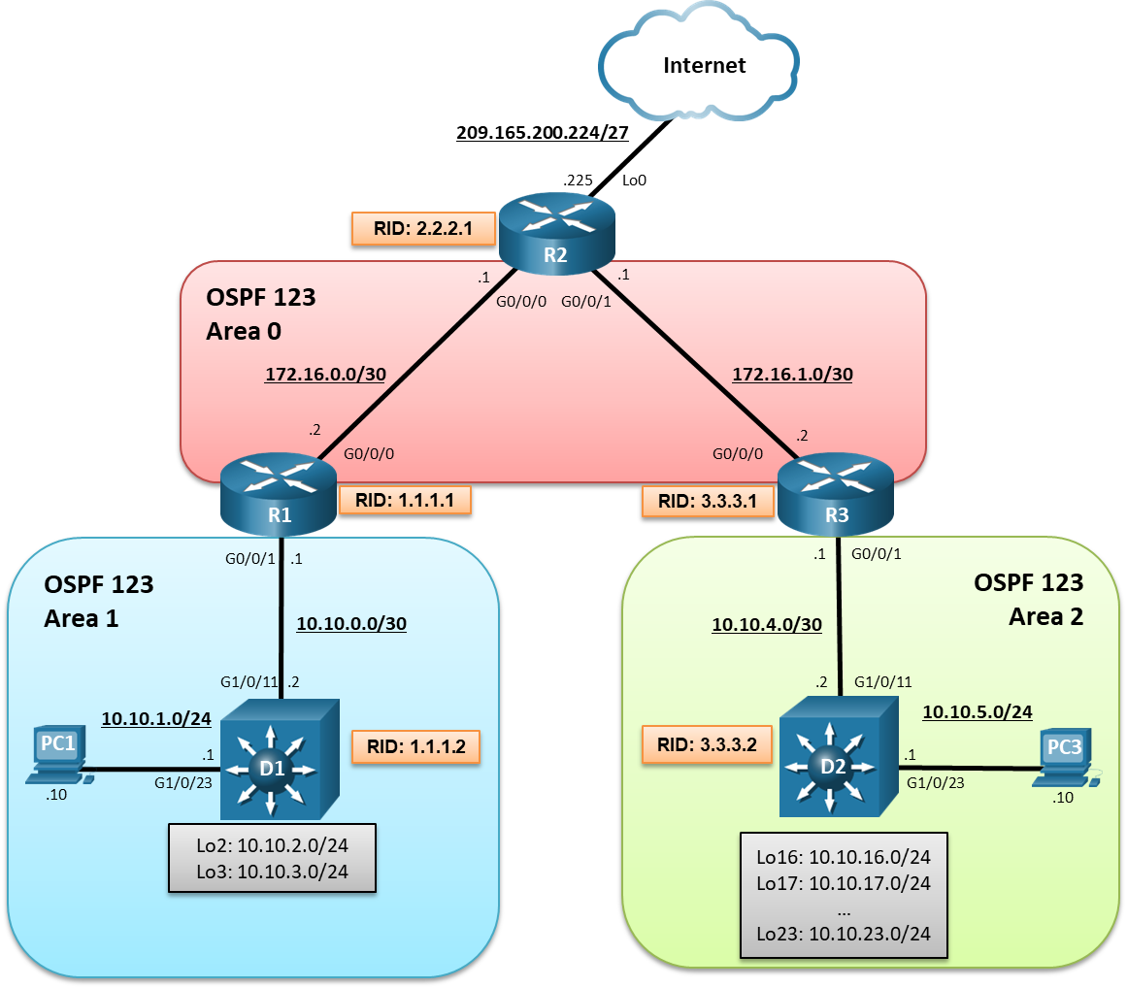

# Addressing Table

| Device | Interface | IPv4 Address |
| --- | --- | --- |
| R1 | G0/0/0 | 172.16.0.2/30 |
| R1 | G0/0/1 | 10.10.0.1/30 |
| R1 | Lo0 | 209.165.200.225/27 |
| R2 | G0/0/0 | 172.16.0.1/30 |
| R2 | G0/0/1 | 172.16.1.1/30 |
| R3 | G0/0/0 | 172.16.1.2/30 |
| R3 | G0/0/1 | 10.10.4.1/30 |
| D1 | G1/0/11 | 10.10.0.2/30 |
| D1 | G1/0/23 | 10.10.1.1/24 |
| D1 | Lo2 | 10.10.2.1/24 |
| D1 | Lo3 | 10.10.3.1/24 |
| D2 | G1/0/11 | 10.10.4.2/30 |
| D2 | G1/0/23 | 10.10.5.1/24 |
| D2 | Lo16 | 10.10.16.1/24 |
| D2 | Lo17 | 10.10.17.1/24 |
| D2 | Lo18 | 10.10.18.1/24 |
| D2 | Lo19 | 10.10.19.1/24 |
| D2 | Lo20 | 10.10.20.1/24 |
| D2 | Lo21 | 10.10.21.1/24 |
| D2 | Lo22 | 10.10.22.1/24 |
| D2 | Lo23 | 10.10.23.1/24 |
| PC1 | NIC | 10.10.1.10/24 |
| PC2 | NIC | 10.10.5.10/24 |

# Objectives

Part 1: Build the Network, Configure Basic Device Settings and Routing

Part 2: OSPFv2 Route Summarization

Part 3: OSPFv2 Route Filtering

# Background / Scenario

Areas make OSPF more scalable and increase efficiency. Consider a large multinational organization with a thousand OSPF routers. If all routers were in a single area, the information contained in their LSDB would be overwhelming. Segmenting the OSPF domain into multiple areas reduces the size of the LSDB for each area, making SPF tree calculations faster, and decreasing LSDB flooding between routers when a link flaps.

To make OSPF even more scalable and efficient, network routes can be summarized and advertised in other areas. As well, specific route filtering can be used to provide more precise control on route propagation.

In this lab, you will configure route summarization and route filtering in a multiarea OSPF version 2 network. This lab was specifically designed to use three routers and two Layer 3 switches. To help visualize the potential of summarization and route filtering, additional loopback interfaces will be configured to simulate LANs and create larger routing tables.

**Note**: This lab is an exercise in developing, deploying, and verifying how OSPF route summarization and filtering operates and does not reflect networking best practices.

**Note**: The router used with this CCNP hands-on lab is a Cisco 4221and the two Layer 3 switches are Catalyst 3560 switches. Other routers and Layer 3 switches and Cisco IOS versions can be used. Depending on the model and Cisco IOS version, the commands available and the output produced might vary from what is shown in the labs.

**Note**: Ensure that the routers and switches have been erased and have no startup configurations. If you are unsure contact your instructor.

**Instructor Note**: Refer to the Instructor Lab Manual for the procedures to initialize and reload devices.

# Required Resources

* 3 Routers (Cisco 4221 with Cisco IOS XE Release 16.9.4 universal image or comparable)
* 2 Switches (Cisco 3650 with Cisco IOS XE Release 16.9.4 universal image or comparable)
* 2 PCs (Windows with terminal emulation program, such as Tera Term)
* Console cables to configure the Cisco IOS devices via the console ports
* Ethernet cables as shown in the topology

# Instructions

## Build the Network, Configure Basic Device Settings and Routing

In Part 1, you will set up the network topology and configure basic settings and interface addressing on the router and Layer 3 switches. You will also configure multiarea OSPFv2 on the OSPF backbone routers R1, R2, and R3. You will manually configure OSPFv2 on D1 and D2.

### Cable the network as shown in the topology.

Attach the devices as shown in the topology diagram, and cable as necessary.

### Configure basic settings for the routers.

* + - 1. Console into each router, enter global configuration mode, and apply the basic settings, interface addressing, and OSPFv2 configuration. The configuration for each device is provided for you below.

**Note**: Routers were configured with OSPFv2.

Open configuration window

Close configuration window

### Configure basic settings for the switches.

* + - 1. Console into the switch, enter global configuration mode, and apply the basic settings and interface addressing. A command list for each switch is provided below.

**Note**: OSPF routing will be manually configured.

Open configuration window

* + - 1. Save the running configuration to startup-config.
      2. Verify the interfaces configured on D1.

D1# **show ip interface brief | include manual**

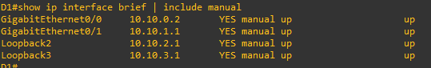

Notice the loopback interfaces configured on D1. Theses interfaces were configured for lab purposes to simulate other LANs.

**Note**: Loopback interfaces were numbered based on the network address (e.g., Lo**2** = 10.10.**2**.0/24) for convenience only.

* + - 1. Verify the interfaces configured on D2.

D2# **show ip interface brief | include manual**

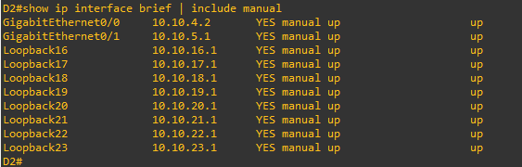

Again, notice the loopback interfaces configured on D1. Theses interfaces were configured for lab purposes to simulate other LANs.

Close configuration window

### Verify routing on R1, R2, and R3.

* + - 1. Verify the routing table of R1 using the **show ip route ospf** command.

Open configuration window

R1# **show ip route ospf | begin Gateway**

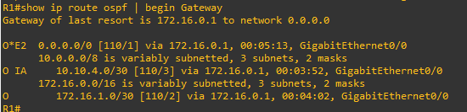

The R1 routing table contains an OSPF internal or intra-area route, and interarea route, and an external route to the default gateway.

* + - 1. Verify the routing table of R2 using the **show ip route ospf** command.

R2# **show ip route ospf | begin Gateway**

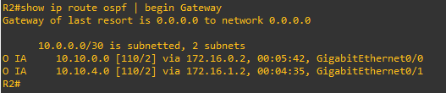

R2 is propagating the static default route and therefore does not have an external type 2 OSPF route (i.e., O* E2) in the routing table like R1 and R3.

* + - 1. Verify the routing table of R3 using the **show ip route ospf** command.

R3# **show ip route ospf | begin Gateway**

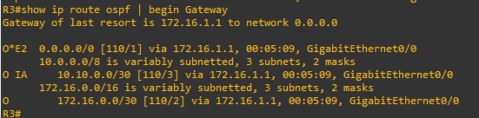

Like R1, R3 has an internal route (LSA 2), an interarea route (LSA 3), and an external route (LSA 5).

The LANs connected to D1 and D2 are not yet advertised.

Close configuration window

### Enable OSPFv2 on D1.

* + - 1. On D1, enable IP routing using the **ip routing** global configuration command.

Open configuration window

D1(config)# **ip routing**

* + - 1. Next, enter the OSPF router configuration mode using process ID 123, assign D1 the router ID 1.1.1.2 and set the reference bandwidth to distinguish between Gigabit Ethernet and FastEthernet interfaces.

D1(config)# **router ospf 123**

D1(config-router)# **router-id 1.1.1.2**

D1(config-router)# **auto-cost reference-bandwidth 1000**

% OSPF: Reference bandwidth is changed.

Please ensure reference bandwidth is consistent across all routers.

**Note**: Setting the reference cost value too high may cause issues with low-bandwidth interfaces.

* + - 1. Next, we need to have D1 advertise all four of its directly connected interfaces. Although this could be accomplished using four separate **network** statements, we will use the wildcard mask to advertise all four interfaces using one **network** statement.

D1(config-router)# **network 10.10.0.0 0.0.3.255 area 1**

D1(config-router)# **end**

*Mar 1 01:01:22.540: %OSPF-5-ADJCHG: Process 123, Nbr 1.1.1.1 on GigabitEthernet1/0/11 from LOADING to FULL, Loading Done

* + - 1. Verify the OSPF routing table on D1.

D1# **show ip route ospf | begin Gateway**

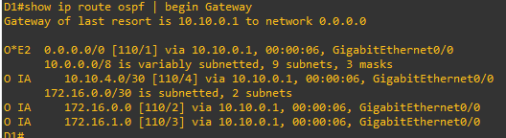

* + - 1. Verify the routing table of R2 using the **show ip route ospf** command.

R2# **show ip route ospf | begin Gateway**

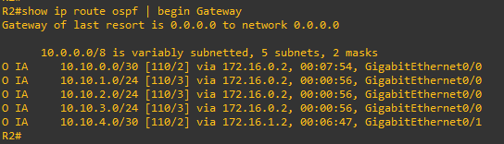

Notice how its routing table now includes routes to the D1 LANs. Notice also how this has increased the number of routing entries.

Close configuration window

### Enable OSPFv2 on D2.

* + - 1. On D2, enable IP routing using the **ip routing** global configuration command.

Open configuration window

D2(config)# **ip routing**

* + - 1. Next, enter the OSPF router configuration mode using process ID 123, assign D2 the router ID 3.3.3.2 and set the reference bandwidth to distinguish between Gigabit Ethernet and FastEthernet interfaces.

D2(config)# **router ospf 123**

D2(config-router)# **router-id 3.3.3.2**

D2(config-router)# **auto-cost reference-bandwidth 1000**

% OSPF: Reference bandwidth is changed.

Please ensure reference bandwidth is consistent across all routers.

**Note**: Setting the reference cost value too high may cause issues with low-bandwidth interfaces.

* + - 1. Advertise the 10.10.4.0/30 and 10.10.5.0 /255 networks. Again, this could be accomplished using separate **network** statements. However, the wildcard mask can be used to advertise both interfaces using one **network** statement as shown.

D2(config-router)# **network 10.10.4.0 0.0.1.255 area 2**

D2(config-router)#

*Mar 1 01:15:02.643: %OSPF-5-ADJCHG: Process 123, Nbr 3.3.3.1 on GigabitEthernet1/0/11 from LOADING to FULL, Loading Done

**Note:** The wildcard mask 0.0.**1**.255 matches both networks 10.10.**4**.0/30 and 10.10.**5**.0/24

* + - 1. Next, advertise the 10.10.16.0/24 through to 10.10.23.0/24 loopback interface networks. Traditionally, this would require 8 **network** statements. But again, the wildcard mask can be used to advertise all 8 interfaces using one **network** statement as shown.

D2(config-router)# **network 10.10.16.0 0.0.7.255 area 2**

D2(config-router)# **end**

**Note**: The wildcard mask 0.0.**7**.255 matches networks 10.10.**16**.0/24 through to 10.10.**23**.0/24.

Close configuration window

### Verify Routing.

* + 1. Verify the routing table of D2 using the **show** **ip route ospf** command.

Open configuration window

D2# **show ip route ospf | begin Gateway**

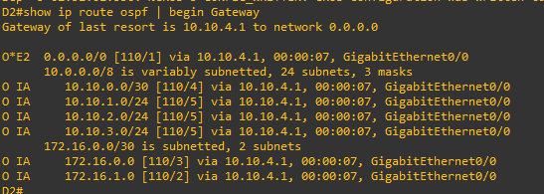

D2 has OSPF route entries for:

* One external OSPF route to the gateway of last resort.
* The four D1 LANs (i.e., 10.10.0.0/30 through 10.10.3.0/24)
* The two Area 0 networks (i.e., 172.16.0.0/30 and 172.16.1.0/30)
  + 1. From R2, verify the routing table using the **show ip route ospf** command.

R2# **show ip route ospf | begin Gateway**

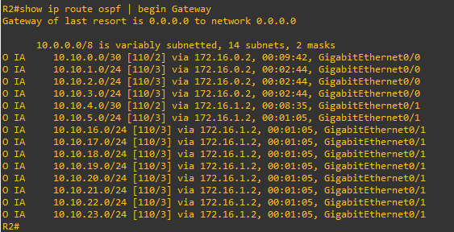

Notice how the routing table of R2 now includes routes to the D1 and D2 LANs. And again, notice how this has increased the number of routing entries.

* + 1. From D1, verify the routing table using the **show ip route ospf** command.

D1# **show ip route ospf | begin Gateway**

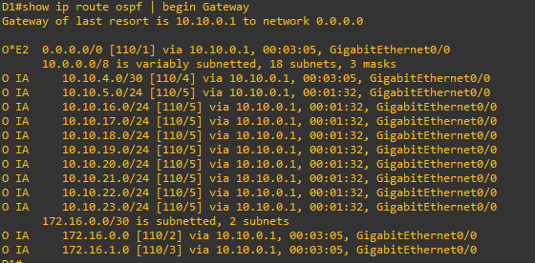

Notice the OSPF routing table now includes the additional interarea routes from D2.

Close configuration window

## OSPFv2 Route Summarization

As shown in Part 1, routing tables increase in the number of entries as more and more networks are connected to the OSPF domain.

To reduce the size of the routing table and LSDB, network prefixes must be summarized. Route summarization improves OSPF performance as fewer network entries are required.

Route summarization involves consolidating multiple routes into a single advertisement. Proper route summarization reduces the bandwidth, memory, and CPU resources consumed by the OSPF process.

OSPF routes can only be summarized between areas. Interarea route summarization is configured on ABRs using the **area** *area-id* **range** *network subnet-mask* [**advertise** | **not-advertise**] [**cost** *metric*] router configuration command.

| Parameter | Description |
| --- | --- |
| **area** *area-id* | * Identifies the area subject to route summarization. |
| *address* | * The summary address designated for a range of addresses. |
| *mask* | * The IP subnet mask used for the summary route. |
| **advertise** | * Enabled by default, it sets the address range status to advertise and generate a type 3 summary LSA. |
| **not-advertise** | * (Optional) Sets the address range status to DoNotAdvertise. * Can be used for route filtering as the type 3 summary LSA is suppressed, and the component networks remain hidden from other networks. |
| **cost** *cost* | * (Optional) Metric or cost for this summary route, which is used during the OSPF SPF calculation to determine the shortest paths to the destination. * The value can be 0 to 16777215. |

In this part, you will learn how to reduce the number of routing entries without compromising access to any networks.

### Configure interarea route summarization on R1.

Area 1 consists of networks 10.10.0.0/30, 10.10.1.0/24, 10.10.2.0/24, and 10.10.3.0/24. To calculate the summary address of these networks:

* + - * 1. List the networks in binary format.
        2. Count the number of left-most matching bits to determine the mask.
        3. Copy the matching bits and add zero bits to determine the network address.

The four networks are listed in binary format.

| **Network** | **1st Octet** | **2nd Octet** | **3rd Octet** | **4th Octet** |
| --- | --- | --- | --- | --- |
| 10.10.**0**.0 | 0000 1010 | 0000 1010 | 0000 00**00** | 0000 0000 |
| 10.10.**1**.0 | 0000 1010 | 0000 1010 | 0000 00**01** | 0000 0000 |
| 10.10.**2**.0 | 0000 1010 | 0000 1010 | 0000 00**10** | 0000 0000 |
| 10.10.**3**.0 | 0000 1010 | 0000 1010 | 0000 00**11** | 0000 0000 |

There are 22 left-most bits that match. Octet 1 and 2 match for a sum of 16 bits. There are 6 left-most bits that match in the 3rd octet which results in a total of 22 bits that match.

A /22 subnet converts to 255.255.252.0.

Therefore, the summary network address of networks 10.10.0.0/30, 10.10.1.0/24, 10.10.2.0/24, and 10.10.3.0/24 is 10.10.0.0 255.255.252.0.

Open configuration window

* + - 1. On the Area 1 ABR router R1, enter OSFP router config mode.

R1(config)# **router ospf 123**

* + - 1. Summarize the D1 LANs using the **area 1 range 10.10.0.0 255.255.252.0** router configuration command.

R1(config-router)# **area 1 range 10.10.0.0 255.255.252.0**

R1(config-router)# **end**

Close configuration window

### Verify the interarea route summarization.

* + - 1. Verify the routing table of R1 using the **show ip route ospf** command.

Open configuration window

R1# **show ip route ospf | begin Gateway**

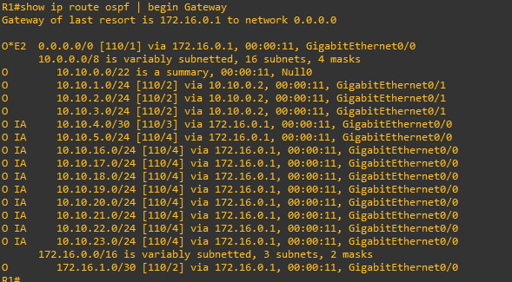

The routing table of the ABR using the summary address adds a discard route entry to the Null 0 interface to prevent routing loops. The portions of the summarized network range will not have a more specific route in the routing table.

* + - 1. Verify the routing table of R2 using the **show ip route ospf** command.

R2# **show ip route ospf | begin Gateway**

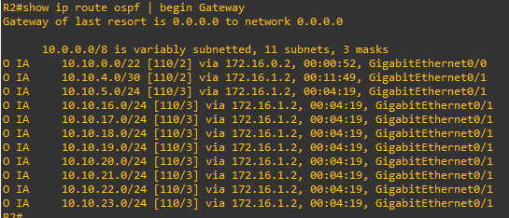

Notice how the previous four route entries for network 10.10.0.0 to 10.0.3.0 have now been summarized onto one route.

Close configuration window

### Configure interarea route summarization on R3.

Area 2 consists of networks 10.10.4.0/30 and 10.10.5.0/24. It also consists of LANs 10.10.16.0/24 through to 10.10.23.0/24. These networks are not contiguous and cannot easily be summarized. For this reason, two summary commands will be configured on R3.

Open configuration window

* + - 1. On R3 enter OSFP router config mode.

R3(config)# **router ospf 123**

* + - 1. The first summary advertisement will be for the 10.10.4.0/30 and 10.10.5.0/24 networks. To summarize they are listed in binary format.

| **Network** | **1st Octet** | **2nd Octet** | **3rd Octet** | **4th Octet** |
| --- | --- | --- | --- | --- |
| 10.10.**4**.0 | 0000 1010 | 0000 1010 | 0000 010**0** | 0000 0000 |
| 10.10.**5**.0 | 0000 1010 | 0000 1010 | 0000 010**1** | 0000 0000 |

There are 23 left-most bits that match. Octet 1 and 2 match for a sum of 16 bits. There are 7 left-most bits that match in the 3rd octet which results in a total of 23 bits that match.

A /23 subnet converts to 255.255.254.0. Therefore, the summary network address of networks 10.10.4.0/30 and 10.10.5.0/24 is 10.10.4.0 255.255.254.0.

Summarize the D2 LANs and using the **area 2 range 10.10.4.0 255.255.254.0** router configuration command.

R3(config-router)# **area 2 range 10.10.4.0 255.255.254.0**

* + - 1. The second summary advertisement will be for the 10.10.16.0/24 through to 10.10.23.0/24 networks. Although all eight networks could be listed in binary format, it is possible to discover the summary addresses by only listing the first network and last network in binary format.

| **Network** | **1st Octet** | **2nd Octet** | **3rd Octet** | **4th Octet** |
| --- | --- | --- | --- | --- |
| 10.10.**16**.0 | 0000 1010 | 0000 1010 | 0001 0**000** | 0000 0000 |
| 10.10.**23**.0 | 0000 1010 | 0000 1010 | 0001 0**111** | 0000 0000 |

There are 21 left-most bits that match. Octet 1 and 2 match for a sum of 16 bits. There are 5 left-most bits that match in the 3rd octet which results in a total of 21 bits that match.

A /21 subnet converts to 255.255.248.0. Therefore, the summary network address of networks 10.10.16.0/24 through to 10.10.23.0/24 is 10.10.16.0 255.255.248.0.

A cost can also be assigned to a summary route by using the **cost** keyword.

Summarize the D2 LANs and assign them a cost of 65 using the **area 2 range 10.10.16.0 255.255.248.0 cost 65** router configuration command.

R3(config-router)# **area 2 range 10.10.16.0 255.255.248.0 cost 65**

Close configuration window

### Verify the interarea route summarization

* + - 1. Verify the routing table of R1using the **show ip route ospf** command.

Open configuration window

R3# **show ip route ospf | begin Gateway**

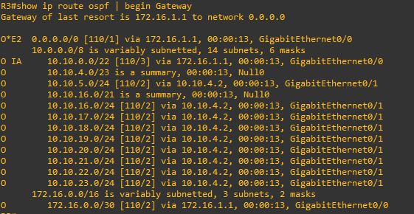

R3 added two discard route entries to the Null 0 interface to prevent routing loops.

* + - 1. Verify the routing table of R2 using the **show ip route ospf** command.

R2# **show ip route ospf | begin Gateway**

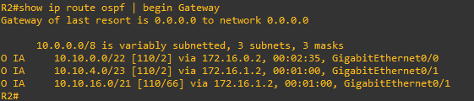

Notice how R2 now has only two route entries for the D2 LANs. Previous to route summarization on R3, R2 had 10 route entries for the D2 LANs. Also notice the cost of the 10.10.16.0/21 route has been influenced.

* + - 1. Verify the routing table of D1 using the **show ip route ospf** command.

D1# **show ip route ospf | begin Gateway**

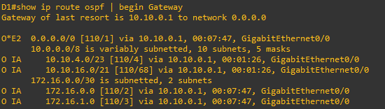

Notice how its routing table is smaller.

* + 1. Verify connectivity to D2.

D1# **ping 10.10.23.1 source 10.10.1.1**

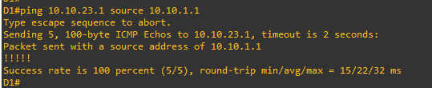

Close configuration window

## OSPFv2 Route Filtering

In this part, you will learn about OSPF route filtering. Route filtering is a method for selectively identifying routes that are advertised or received from neighbor routers. Route filtering may be used to manipulate traffic flows, reduce memory utilization, or improve security.

Filtering of routes with vector-based routing protocols is straightforward. This is because the routes are filtered as routing updates and are advertised to downstream neighbors. However, with link-state routing protocols such as OSPF, every router in an area shares a complete copy of the link-state database. Therefore, filtering of routes generally occurs as routes enter the area on the ABR.

The following sections describe three techniques for filtering routes with OSPF.

* **Filtering with Summarization** – An easy router filtering method is to use the **area** *area-id* **range** *network subnet-mask* **not-advertise** router config command. However, it is limited in its ability to filter.
* **Area Filtering** - OSPF area filtering is accomplished by using the **area** *area-id* **filter-list prefix** *prefix-list-name* {**in** | **out**} router config command on the ABR.
* **Local OSPF Filtering** – To enable a route to exist in the OSPF LSDB and prevent it from being installed in the local routing table, use the distribute list feature.

### Filter with summarization.

* + - 1. As an example of filtering with summarization, we will remove the last route summarization command configured on R3.

Open configuration window

R3(config-router)# **no area 2 range 10.10.16.0 255.255.248.0**

* + - 1. On D1, verify that all of the 1010.16.0/24 through 10.10.23.0/24 networks are in the routing table.

D1# **show ip route ospf | begin Gateway**

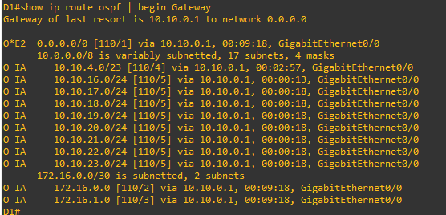

The D2 LANs are in the routing table of D1.

* + - 1. Now, on R3, filter the 10.10.18.0/24 network from being advertised to another area using the **not-advertise** keyword.

R3(config-router)# **area 2 range 10.10.18.0 255.255.255.0 not-advertise**

* + - 1. On D1, verify the routing table.

D1# **show ip route ospf | begin Gateway**

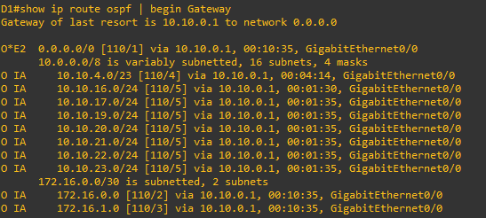

Notice that the 10.10.18.0/24 prefix is no longer in the routing table of D1.

Close configuration window

### Use area filtering.

On R1, filter the 10.10.2.0/24 network from being advertised into OSPF Area 0 by creating a prefix list and then referencing the list in the **area** *area-id* **filter-list prefix** *prefix-list-name* {**in** | **out**} command on R1. You will then filter the 10.10.3.0 network from being propagated into Area 2.

Open configuration window

* + - 1. O R1, remove the route summarization command that was configured in Part 2.

R1(config-router)# **no area 1 range 10.10.0.0 255.255.252.0**

R1(config-router)# **exit**

* + - 1. Verify that the routing table of R2 has the 4 entries from Area 1.

R2# **show ip route ospf | include 0/0/0**

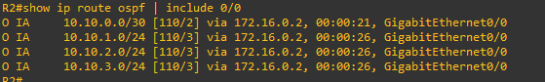

* + - 1. Create the following prefix list on R1 to deny 10.10.2.0/24 but permit everything else.

R1(config)# **ip prefix-list FILTER-1 deny 10.10.2.0/24**

R1(config)# **ip prefix-list FILTER-1 permit 0.0.0.0/0 le 32**

* + - 1. Enter OSPF router configuration mode and assign the prefix filter incoming in Area 0.

R1(config)# **router ospf 123**

R1(config-router)# **area 0 filter-list prefix FILTER-1 in**

* + - 1. Verify that 10.10.2.0 is not in the routing table of R2.

R2# **show ip route ospf | include 0/0/0**

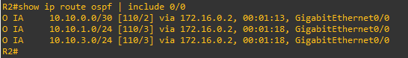

Notice that the 10.10.2.0/24 prefix has been filtered from Area 0 is no longer in the R2 routing table.

* + - 1. Verify that D2 has a route entry for 10.10.3.0/24.

D2# **show ip route | inc 10.10.3.0**



* + - 1. On R3, create the following prefix list to deny 10.10.3.0/24 but permit everything else.

R3(config)# **ip prefix-list FILTER-1 deny 10.10.3.0/24**

R3(config)# **ip prefix-list FILTER-1 permit 0.0.0.0/0 le 32**

* + - 1. On R3, enter OSPF router configuration mode and assign the prefix filter outgoing from Area 0.

R3(config)# **router ospf 123**

R3(config-router)# **area 0 filter-list prefix FILTER-1 out**

* + - 1. Verify that 10.10.3.0 is not in the routing table of D2.

D2# **show ip route | inc 10.10.3.0**



Close configuration window

### Use local OSPF filtering.

A distribute list should not be used for filtering prefixes between areas. A distribute list is configured using the **distribute-list** {*acl-number* | *acl-*name | **prefix** *prefix-list-name* | **route-map** *route-map-name*} **in** router configuration command.

In this step, we will filter the 10.10.20.0/24 network from entering the R2 routing table.

Open configuration window

* + - 1. On R2, verify that 10.10.20.0 is in the routing table.

R2# **show ip route | include 10.10.20.0**

O IA 10.10.20.0/24 [110/3] via 172.16.1.2, 01:32:39, GigabitEthernet0/0/1

* + - 1. Next enter an ACL called OSPF-FILTER that denies 10.10.20.0/24 from entering the R2 routing table.

R2(config)# **ip access-list standard OSPF-FILTER**

R2(config-std-nacl)# **deny 10.10.20.0 0.0.0.255**

R2(config-std-nacl)# **permit any**

R2(config-std-nacl)# **exit**

* + - 1. On R2, enter OSPF router configuration mode and assign the distribute list filter.

R2(config)# **router ospf 123**

R2(config-router)# **distribute-list OSPF-FILTER in**

R2(config-router)# **end**

* + - 1. Verify that 10.10.20.0 prefix is not in the routing table of R2.

R2# **show ip route | include 10.10.20.0**

* + - 1. Verify that the 10.10.20.0 prefix is still being propagated in the area. Verify the routing table of R1.

R1# **show ip route | include 10.10.20.0**



The 10.10.20.0/24 prefix still appears in the routing table of R1. The distribute list only filtered the route from entering the routing table on R2 but is still in the LSDB for Area 0.

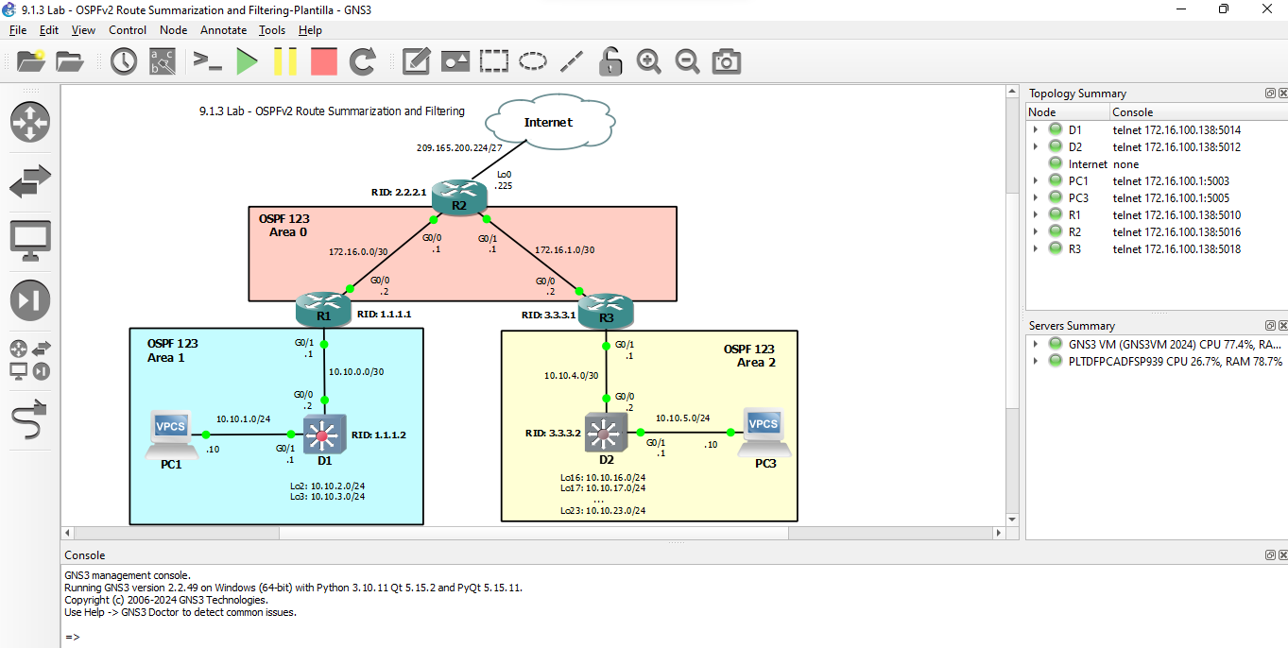

Close configuration window

# Router Interface Summary Table

| Router Model | Ethernet Interface #1 | Ethernet Interface #2 | Serial Interface #1 | Serial Interface #2 |
| --- | --- | --- | --- | --- |
| 1800 | Fast Ethernet 0/0 (F0/0) | Fast Ethernet 0/1 (F0/1) | Serial 0/0/0 (S0/0/0) | Serial 0/0/1 (S0/0/1) |
| 1900 | Gigabit Ethernet 0/0 (G0/0) | Gigabit Ethernet 0/1 (G0/1) | Serial 0/0/0 (S0/0/0) | Serial 0/0/1 (S0/0/1) |
| 2801 | Fast Ethernet 0/0 (F0/0) | Fast Ethernet 0/1 (F0/1) | Serial 0/1/0 (S0/1/0) | Serial 0/1/1 (S0/1/1) |
| 2811 | Fast Ethernet 0/0 (F0/0) | Fast Ethernet 0/1 (F0/1) | Serial 0/0/0 (S0/0/0) | Serial 0/0/1 (S0/0/1) |
| 2900 | Gigabit Ethernet 0/0 (G0/0) | Gigabit Ethernet 0/1 (G0/1) | Serial 0/0/0 (S0/0/0) | Serial 0/0/1 (S0/0/1) |
| 4221 | Gigabit Ethernet 0/0/0 (G0/0/0) | Gigabit Ethernet 0/0/1 (G0/0/1) | Serial 0/1/0 (S0/1/0) | Serial 0/1/1 (S0/1/1) |
| 4300 | Gigabit Ethernet 0/0/0 (G0/0/0) | Gigabit Ethernet 0/0/1 (G0/0/1) | Serial 0/1/0 (S0/1/0) | Serial 0/1/1 (S0/1/1) |

**Note**: To find out how the router is configured, look at the interfaces to identify the type of router and how many interfaces the router has. There is no way to effectively list all the combinations of configurations for each router class. This table includes identifiers for the possible combinations of Ethernet and Serial interfaces in the device. The table does not include any other type of interface, even though a specific router may contain one. An example of this might be an ISDN BRI interface. The string in parenthesis is the legal abbreviation that can be used in Cisco IOS commands to represent the interface.

End of document